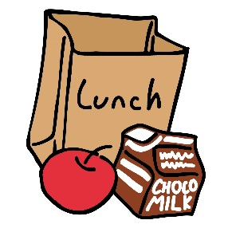Box Lunches for 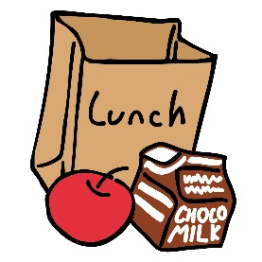
Field Trips & Early Release Days
The Kitchen staff will prepare a healthy and delicious boxed lunch for your child’s field trip and Early Release Days.
Lunch Choices
K-12 $3.25 per student
Free for students with free meal benefits. $0.40 for students with reduced benefits.
1.) Ham and Cheese Sandwich  Carrot Sticks  Apple  Bag of Chips  Water or Juice | 2.) Turkey and Cheese Sandwich  Carrot Sticks  Apple  Bag of Chips  Water or Juice | 3.) Bagel and String Cheese  Carrot Sticks  Apple  Bag of Chips  Water or Juice

Please return this form to your classroom teacher or Cafeteria Manager.

Note to Teachers: Please Collect and return all forms to the kitchen 1 week before the field trip. Early Release Days require a 48 hour notice.
Name:_________________ Homeroom:_______________ Choice #:________________
Date Wanted:________________ *Money will be deducted from your lunch account.

