

CALENDAR

2/12-2/28 Pet Food Drive/Boxes in UME Lobby

2/12 100th day of school activities

2/16 Trimester ends

2/18-23 Winter break

2/26, 27 & 28 Early Childhood Registration

3/2 UME 4th grade art class to Norman Rockwell

3/9 Family Movie Night, Elem Cafeteria

3/3 Read Across America Day

3/5 NMC 4th grade art class to Norman

Rockwell

3/9 Report cards go home

3/13 UME K-3rd grade Talent Show

3/14 UME Grades 4-6 Talent Show

3/16 ½ day (Dismissal at 11:40)

3/20 EK-6th grade STEM presentation in UME gym all day

3/21 6:30 pm Grades K-3 parenting workshop at UME Library presented by South Berkshire Kids

**SOUTHERN BERKSHIRE REGIONAL SCHOOL DISTRICT ELEMENTARY NEWSLETTER Feb/Mar 18**

Principal's Message

100th Day of School Activities on Monday, Feb 12th

* UME PK is learning about winter and penguins. They made sock penguins and Oreo cookie penguins.
* NMC’s EK/K class are making crowns with 10 sets of 10 different items; buttons, etc.
* UME Kindergarten students will be imagining themselves as 100 year olds. They will also make a ‘100th day snack’.
* UME 1st grade has a “fashion show” wearing tee shirts they have decorated.
* NMC’s first grade will be decorating capes with 100 various items.
* UME 2nd grade students have been digitalized to look 100 years old.
* UME 3rd grade are each making 50 chain links with each link representing an act of kindness they have shown this year.

Regular school attendance is essential to your child’s success in school. Try to schedule appointments and family trips outside of school hours. We often talk about preparing children to be “college and career ready” as our goal. Learning to be on time is one of those skills. Being in school every day, on time, insures that your child will not miss out on learning. Our elementary school day starts at 8:10. Teachers begin the day by introducing the schedule, updating the class on various items and other things that get the class off to a productive start. Being even a few minutes late causes children to miss this important part of the school day. Please make being on time to school a priority. Thank you for supporting your child’s education.



**FIFTH GRADE ART PROJECT**

As a final project in the study of volume/mass/density and three dimensionality, the 5th grade art class was asked to:

* Select a space in our school. Think of simple ways you could alter or re-envision the space by adding something or changing something.
* What kind of space would you like to create?
* How could you transform the space into something different from your ordinary world? Even a ball of string can change a space.
* What ideas can you think of? Sketch them out on a piece of paper.

We talked about the ideas as a class and decided on one to make happen!

Some of the students in the Mrs. Hutchinson's class, Makayla Carpenter, Madeline Collingwood, Emma Hare, Madison Humes, Stella Lennex, Diana Splawn and Makenna Weiler, decided to make motivational signs to be placed in the Undermountain and Mount Everett schools. On multiple posters, these students painted motivational messages to uplift the spirits of all who might see them and to remind students that "mistakes prove that you are trying" and "to be the change you wish to see in the world". This project can be a reminder of self-empowerment, motivation, effort, commitment, respect and kindness towards yourself and others. Here is one of the signs that were created.

Conversations about school…

When you think of parent involvement, do you picture parents volunteering in classrooms? That’s one way – but research shows that supporting your child’s education at home is even more important. Try these conversation starters:

“Let’s see what you brought home.” Look at completed work to see what your child is learning and how well she is doing. Respond to notes from her teacher and sign her weekly or daily folder if required.

“Show me what you have for homework.” It’s your child’s job to do her homework, but you play a role, too. Make sure she knows what she’s supposed to do and glance over the work when it’s completed.

“Describe a book you enjoyed today.” This helps you know what your child prefers to read. Encourage her reading and listening skills by reading aloud to her and letting her read to you.

“Tell me what you learned that you’d like to know more about.” Use your child’s interests for ideas on activities to share. If she likes geometry, you could hunt for shapes together. If she’s fascinated by how animals adapt to winter, take her to the library to research the subject of to the zoo to see live animals.

From “Home & School Connection”

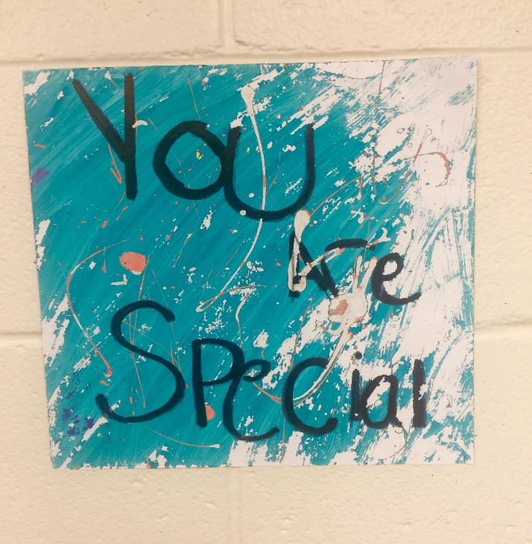

**REMINDER – BOX TOPS FOR EDUCATION WILL BE COLLECTED SOON.**

To the UME PTO for setting up the “Giving Tree” in the elementary lobby with stars hanging from the tree with teachers’ ‘wish list’ for items for their classroom. Also a huge thank you to all of the families who gave these gifts to the classrooms. These gifts will support instruction and enhance learning. We have such a thoughtful and giving group of parents on our PTO and throughout our school! Teachers were very appreciative and pleasantly surprised by the meaningful gifts that resulted from the “Giving Tree”.

Notes from the Music Room...

Things are busy in our classroom these first few months of 2018!

To ring in the new year, all classes had an opportunity to play a vast collection of bells, discovering what makes sound vary from bell to bell and what they were used for.

* Pre-K, EK and first graders are exploring finding steady beat - moving to all kinds of recorded music and playing unusual percussion instruments.
* First and second graders are working on finding rhythms and pitches in our newly gifted boomwhackers (thanks to anonymous kindness). Moving with scarves is fun, too!
* We are warming up to begin learning the recorder in the third grade classes. Reviewing note reading in the fourth grade classes, we will form recorder and ukulele ensembles in the spring.
* Wednesdays include Open Studio time available during lunch/recess time for upper elementary students to receive extra help on band instruments, have an opportunity to explore the arts library and more.
* Fifth and sixth grade Music Lab students have explored creative thinking, improvisation, arranging and will be composing soon, using keyboards and iPads.

Please feel free to stop by for a visit in our music classes. We’d love to see you and welcome your participation!

Elizabeth Petty 

**THANK YOU, THANK YOU, Thank you**

**T**

UME Math Club

5th grade students have a Math Club! Math Club students meet once a week during lunch and recess to enjoy fun, yet challenging brainteasers that engage mathematical thinking. Activities include thinking games such as *Tangoes, Rush Hour, Kanoodle,* and *Mastermind*, as well as *Math Olympiad* questions, and more! Thank you to the UME PTO for sponsoring this club where students solve puzzles and math problems using logic, reasoning, and perseverance!

