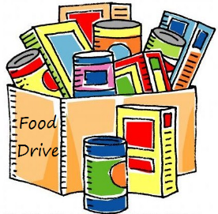 Food Drive 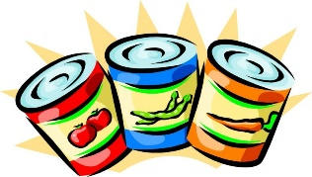
In support of the Sheffield Food Assistance Program in the upcoming holidays
11/13 - 11/16
It is crucial for the Food Bank to have enough for Thanksgiving and Christmas, so please consider bringing in some food and dropping it off at the entrance:
- Canned soups and vegetables
- Jelly and peanut butter
- Stuffing and cake mixes
- Pasta and spaghetti
Just check to make sure they are still good!

Any questions please contact Nadia Makuc
namakuc@sbrsd.org

