What Counts as a Reimbursable Lunch?

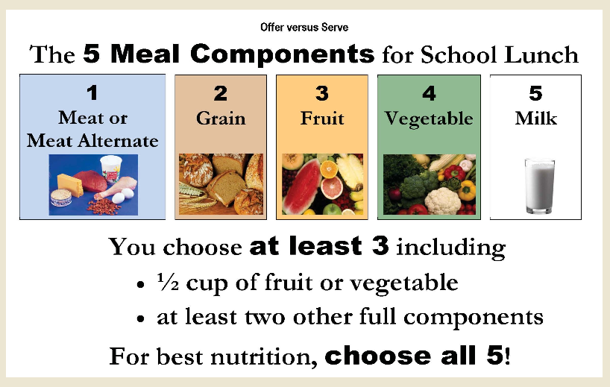

Benefits for Students:
-Students learn how to build a balanced meal, a
lifelong skill important for healthy living.

-Research shows when a child’s nutritional
needs are met, the child is more attentive in
class, has better attendance, & fewer
disciplinary problems.

-USDA research shows children who
participate in National School Lunch Programs
eat healthier compared to those who do not
participate.

-School districts participating in the National
School Lunch Program are required to have a
wellness policy which addresses obesity,
promotes healthy eating, and encourages
physical activity among students.

FOR PARENTS
-School lunch offers parents a convenient way to provide a nutritious lunch for their children at the lowest possible price. If all five components of a meal were purchased separately it would cost $4.50, but when purchased as a reimbursable meal it would cost $2.75.

-This saves $8.75 per week. That is about $317 dollars saved over the whole school year!

